String Problems. Easy
- Pig Latin. Write a method the takes in a string and returns the pig latin equivalent. Pig Latin takes the first consonant, moves it to the end of the word and places “ay” at the end. If the string starts with a vowel do nothing. “pig” -> “igpay”, “banana” -> “ananabay”, “egg” -> “egg”.
Note: The possible java solution below adds the rule that if the input is only 1 letter, return as is.
Solution:
- Check if the input word starts with a constant.
- If it is, create the new word with a suffix according to the rule.
- Return a copy of the input word, otherwise
Possible java Solution:
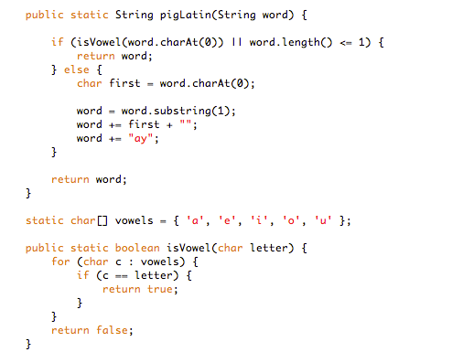
- Anagrams. Write a method to decide if two strings are anagrams or not. An anagram is a word formed by rearranging the letters of another word, e.g., iceman is an anagram of cinema.
Solution:
(ver1)
- Write a function which return lower-cased sorted version a string
- Return a result of comparing lower-cased sorted versions of input strings
(ver2)
- Create an array with 256 zero elements representing ASCII code chart.
- Passing through the 1st string, add 1 to the cell which index corresponds to ASCII code of a current char
- Passing through the 2nd string, check if the cell with the index corresponding to ASCII code of a current char has 0 value
  - If the cell’s value is zero, return False
  - if the cell’s value is non-zero, subtract 1 and continue the loop
- If the loop wasn’t broken, return True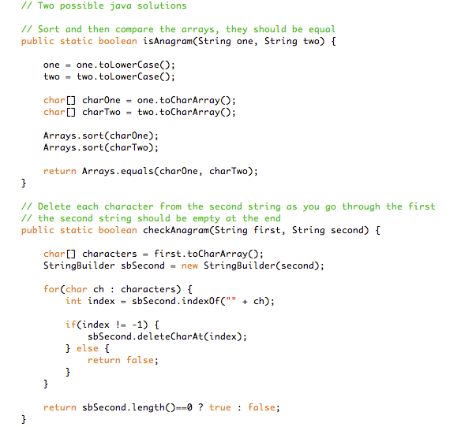

- Palindrome. Determine if a given string is a palindrome. A palindrome is a string that is the same forwards as backwards, ignoring letter case, punctuation marks and word dividers. For example, “racecar” and “Amor, Roma” are palindromes, “abcd” is not. We limit the punctuation marks to ignore by the period, comma, question mark, exclamation point, apostrophe, colon, semi colon and hyphen.
Possible Python solution:

def is_palindrome(word):
n = len(word)
i, j = 0, n-1
while i != j:
a, b = word[i].lower(), word[j].lower()
if a in "., /';:?!-":
i += 1
elif b in "., /';:?!-":
j -= 1
elif a != b:
return False
else:
i += 1
j -= 1
return True

Possible java solution (assumed there are not whitespace or punctuation marks in a given string):
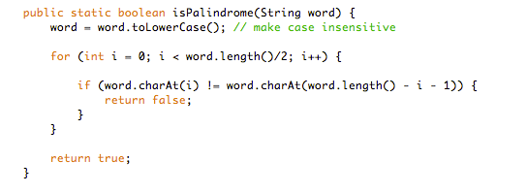
- Reverse String. Write code to reverse a C-Style String. (C-String means that “abcd” is represented as five characters, including the null character.)
Solution:
- Using additional space O(n) and time complexity O(n)
  - Create an empty char array of size strlen(n)+1, initialize with ‘\0’
  - Reverse for loop to copy characters from back of string to front of empty array
  - Return the new array
- Using no additional space and time complexity O(n/2).
Run a for loop from beginning till the middle of the array, continuously swapping characters with the back
swap (s[i], s[s.Length - 1 - i])

- Finding Duplicates. Print out the duplicate elements in a given string.
Hint. This is doable in linear time with a single pass. Participant should ask clarifying question about what is the alphabet size (eg, ascii, or 26 lower case). Also clarify whether to print all occurrences or print once fo ea.
Solution:
- Create an array with 256 zero elements representing ASCII code chart
- Passing through the string, check a value at the the cell with the index corresponded to ASCII code of a current char
    - If the value is zero, add 1
    - If the value is bigger zero, it means this char is duplicate
    - Print out the char, if the value is 1
    - Add 1 to the value
//Java’s charAt() is O(1), a direct access to Array
private static void f(String a) {
int cnt[] = new int[256];
for (int i = 0; i < a.length(); i++) {
int idx = a.charAt(i);
if (cnt[idx] == 1) {
System.out.format("dup %s at %d %n",a.charAt(i), i);
}
cnt[idx]++;
}
}

String Problems. Advanced
- Unique Characters. Implement an algorithm to determine if a string has all unique characters. What if you cannot use additional data structures?
SOLUTION

You may want to start off with asking your interviewer if the string is an ASCII string or a Unicodestring. We'll assume for simplicity that the character set is ASCII. If not, we would need to increase the storage size, but the rest of the logic would be the same. Given this, one simple optimization we can make to this problem is to automatically return false if the length of the string is greater than the number of unique characters in the alphabet. After all, you can't have a string with 280 unique characters if there are only 256 possible unique characters. Our first solution is to create an array of boolean values, where the flag at index i indicates whether character i in the alphabet is contained in the string. If you run across this character a second time, you can immediately return false. The code below implements this algorithm.
public boolean isUniqueChars2(String str)
{
if (str.lengthQ > 256)
return false;
boolean[] char_set = new boolean[256];
for (int1 = 0; i < str.lengthQ; i++)
{
int val = str.charAt(i);
if (char_set[val])
{ // Already found this char in string
return false;
}
char_set[val] = true;
}
return true;
}
The time complexity for this code is O(n) , where n is the length of the string. The space complexity is O(1).

We can reduce our space usage by a factor of eight by using a bit vector. We will assume, in the below code, that the string only uses the lowercase letters a through z. This will allow us to use just a single int.
public boolean isUniqueChars(String str)
{
int checker = 0;
for (int 1=0; i < str.length(); i++)
{
int val = str.charAt(i) - 'a';
if((checker & ( 1 « val)) > 0)
{
return false;
}
checker |= (1 « val);
}
return true;
}
Alternatively, we could do the following:
- Compare every character of the string to every other character of the string. This will take O(n^2) time and O(1)space.
- If we are allowed to modify the input string, we could sort the string in O(n log(n)) time and then linearly check the string for neighboring characters that are identical. Careful, though: many sorting algorithms take up extra space. These solutions are not as optimal in some respects, but might be better depending on the constraints of the problem.

- Replace all spaces. Write a method to replace all spaces in a string with '%20'. You may assume that the string has sufficient space at the end of the string to hold the additional characters, and that you are given the "true" length of the string. (Note: if implementing in Java, please use a character array so that you can perform this operation in place.)
EXAMPLE
Input: "Mr John Smith"
Output: "Mr%20John%20Smith"
Solution:

A common approach in string manipulation problems is to edit the string starting from the end and work backwards. This is useful because we have extra buffer at the end, which allows us to change characters without worrying about what we're overwriting.
We will use this approach in this problem. The algorithm works through a two scan approach. In the first scan, we count how many spaces there are in the string. This is used to compute how long the final string should be. In the second pass, which is done in reverse order, we actually edit the string. When we see a space, we copy %20 into the next spots. If there is no space, then we copy the original character.

public void replaceSpaces(char[] str, int length) {
int spaceCount = 0 , newLength, i;
- for (i = 0; i < length; i++) {
if (str [i] == ‘ ’) {
spaceCount++;
- }
- newLength = length + spaceCount * 2;
- str[newLength] = ‘\0’;
- for (i = length-1; i >= 0; i--) {
if (str[i] == ‘ ’) {
str[newLength-1] = ‘0’;
str[newLength-2] = ‘2’;
str[newLength-3] = ‘%’;
newLength -= 3;
} else {
str[newLength -1] = str[i];
newLength--;
}
- }
- Reverse words. Given a string containing a set of words separated by whitespace transform it to a string in which the words appear in the reverse order. For example, “Alice likes Bob” transforms to “Bob likes Alice”. We do not need to keep the original string.
Solution (http://www.programminginterview.com/content/strings)
ver 1
- Identify the words by token scanning
- Put them on a stack scanning the string from left to right
- Pop them back off to get the words you inserted in reverse order

Even though that solution would work, it requires a lot of additional space.

ver 2 (in linear time and in-place)
- Reversing the whole string gets the words to their correct relative positions. However, for words that are longer than one character, their letters appear in reverse order. For example, “ram is costly” reversed yields “yltsoc si mar”
- So the next step is reversing the individual words.
void reverseString(char* str, int start, int end) // Reverse string in-place in O(n)
{
if (str == NULL) return;
while (start < end) {
char temp = str[start];
str[start] = str[end];
str[end] = temp;
start++;
end--; }
}
}
void reverseWords(char* input)
{
reverseString(input, 0, strlen(input) - 1); // First reverse the entire string
// Reverse each word
int startWord = 0;
for (int i = 0; i <= strlen(input); i++) {
if (input[i] == ' ' || input[i] == 0) {
reverseString(input, startWord, i - 1);
startWord = i + 1;
}
} }
- Generate all permutations of string. Write a program which generates all permutations of a string. Tell the complexity of the solution.
Solution:
We remove the first character and recurse to get all permutations of length N-1, then we insert that first character into N-1 length strings and obtain all permutations of length N . The complexity is O(N!) because there are N! possible permutations of a string with length N, so it’s optimal. I wouldn’t recommend executing it for strings longer than 10-12 characters though, it’ll take a long time. Not because it’s inefficient, but inherently there are just too many permutations.

def permutations(word):
if len(word) == 1:
return [word]

#get all permutations of length N-1
perms = permutations( word[1:] )
char = word[0]
result = [ ]

#iterate over all permutations of length N-1
for perm in perms:
#insert the character into every possible location
for i in range( len( perm)+1):
result.append( perm[:i] + char + perm[i:])

return result

The above solution uses O(N!) space as well as O(N!) time. Here is a version in C which only uses the space for the original string.
void swap(char* a, char* b) {
char t = *a; *a = *b; *b = t;
}
void permute_aux(char *orig, char *str, int len)
{
int i;
if (len == 0) return;
if (len == 1) { /* bottom of recursion, print! */
printf("%s\n", orig);
return;
}
permute_aux(orig, str+1, len-1);
for (i = 1; i < len; i++) {
swap(&str[0], &str[i]);
permute_aux(orig, str+1, len-1);
swap(&str[0], &str[i]);
}
}
void permute(char *str, int len)
{
permute_aux(str, str, len);
}
- Remove Duplicate. Design an algorithm and write code to remove the duplicate characters in a string without using any additional buffer. NOTE: One or two additional variables are fine. An extra copy of the array is not. Write the test cases for this method.
Solution: Set or HashTable data structure perfectly suits our purpose. It stores keys and provides constant time search for key existence. So, we’ll loop over the characters of the string, and at each iteration we’ll check whether we have seen the current character before by searching the set. If it’s in the set then it means we’ve seen it before, so we ignore it. Otherwise, we include it in the result and add it to the set to keep track for future reference. The code is easier to understand:
def removeDuplicates(string):
result=[]
seen=set()
for char in string:
if char not in seen:
seen.add(char)
result.append(char)
return ''.join(result)
The time complexity of the algorithm is O(N) where N is the number of characters in the input string, because set supports O(1) insert and find. This is an optimal solution to one of the most common string interview questions. Note: Complexity of insert and find for set or hash table is language and implementation dependent. Average case is mostly constant, but worst case can be logarithmic or even linear. But in an interview setting I think it’s safe to assume constant time insert and find.

